|  |  |  |  |
| --- | --- | --- | --- |
| **Coure Code:** | **ECE1002** | **Course Name:** | **Semiconductor Devices and Circuits Lab** |
| **Faculty In – Charge:** | **Dr. Pradeep Naryanan. S.** | **Department:** | **SENSE** |
| **Name of the Student:** | **Aryan Pandey** | **Registration Number:** | **20BLC1087** |
| **Experiment No.:** | **9** | **Date of Experiment:** | **14.06.2021** |
| **Name of the Experiment:** | **DESIGN A CIRCUIT TO AMPLIFY THE LOW LEVEL SIGNAL USING A TRANSISTOR AS AN AMPLIFIER UNDER COMMON EMITTER CONFIGURATION** | | |

**OBJECTIVE: -**

To design and verify the low-level signal amplification using a transistor as an amplifier in Common Emitter configuration using LTSPICE Simulator and observe its characteristics.

**TOOLS: -**

LTSPICE XVII Simulator.

**THEORY**

**TRANSISTOR AS AN AMPLIFIER: -**

The transistor raises the strength of a weak signal and hence acts an amplifier. The transistor amplifier circuit is shown in the figure below. The transistor has three terminals namely emitter, base and collector. The emitter and base of the transistor are connected in forward biased and the collector base region is in reverse bias. The forward bias means the P-region of the transistor is connected to the positive terminal of the supply and the negative region is connected to the N-terminal and in reverse bias just opposite of it has occurred.

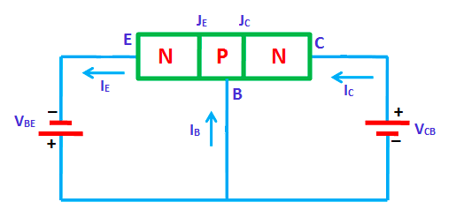

The input signal or weak signal is applied across the emitter base and the output is obtained to the load resistor RC which is connected in the collector circuit. The DC voltage VEE is applied to the input circuit along with the input signal to achieve the amplification. The DC voltage VEE keeps the emitter-base junction under the forward biased condition regardless of the polarity of the input signal and is known as a bias voltage.

**PROCEDURE**

**CONSTRUCTION PROCEDURE: -**

1. We are using transistor “BC547B”. draw a NPN transistor pick a new transistor and choose a suitable transistor.
2. Take two voltmeters , fix one voltmeter to 22V and the other voltmeter let us do ac and dc load analysis respectively later on.
3. Take three resistors of 39 kΩ,1.5 kΩ,3.9 kΩ and 1 kΩ
4. Take 3 Capacitors of 10 µF, 220 µF and 10 µF.
5. Take two grounds, Name label VOUT and VIN
6. Arrange the 2 grounds after choosing.

Sine Simulation: -

1. The Voltmeter which provides the Input, needs to be set.
2. Click on Edit Simulation Command
3. In Transient Analysis,

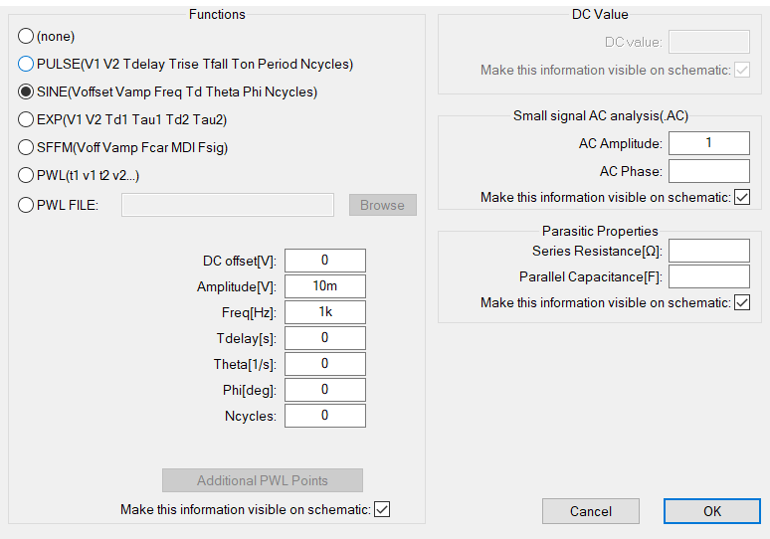

1. Set the AC analysis in sine as shown above.
2. Also select “;op” for the analyisis
3. Arrange your circuit in the following way: -

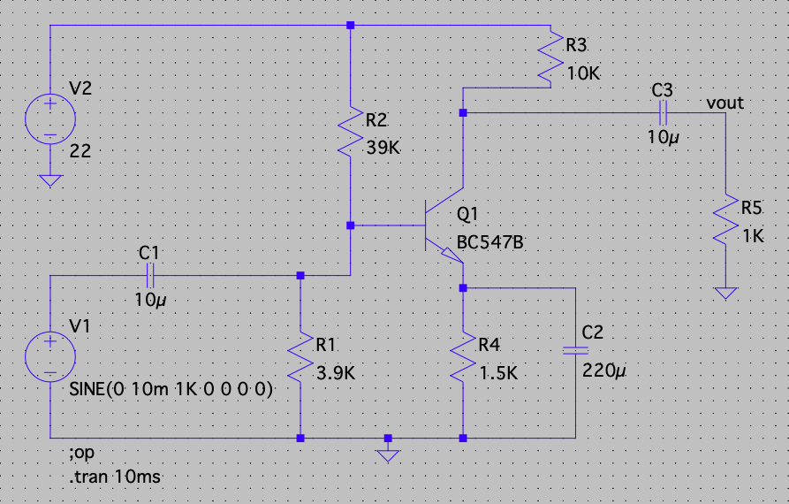

Input Output for both AC and DC analysis of load in transistors place your curser on the VIN label for the input and place your cursor on the VOUT label for VOUT.

VERIFICATION OF THE LOW LEVEL SIGNAL USING NPN TRANSISTOR AS AN AMPLIFIER UNDER COMMON EMITTER CONFIGURATION: -

The common emitter circuit configuration is used in many areas of electronic circuit design: as an audio amplifier, as a basic switch for logic circuits, as a general analogue amplifier and in many other applications.

The common emitter circuit configuration provides voltage gain combined with a moderate current gain, as well as a medium input and a medium output impedance. As such the common emitter configuration is a good all round circuit for use in many applications.

It is also worth noting at this stage that the common emitter transistor amplifier inverts the signal at the input. Therefore if a waveform that is rising enters the input of the common emitter amplifier, it will cause the output voltage to fall. In other words it has a 180° phase change across the circuit.

Dependent upon the actual electronic circuit design itself, the common emitter does not use too many electronic components, sometimes as few as two resistors, although if the bias needs setting for analogue circuits, then four resistors and three capacitors may be used.

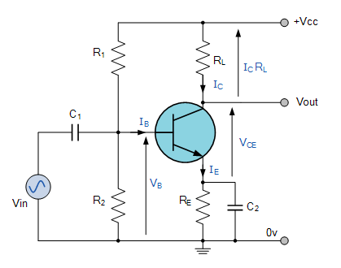

Components Required: -

* Voltmeter
* Resistors
* Capacitors
* Ground
* Wires

Logic Diagram: -

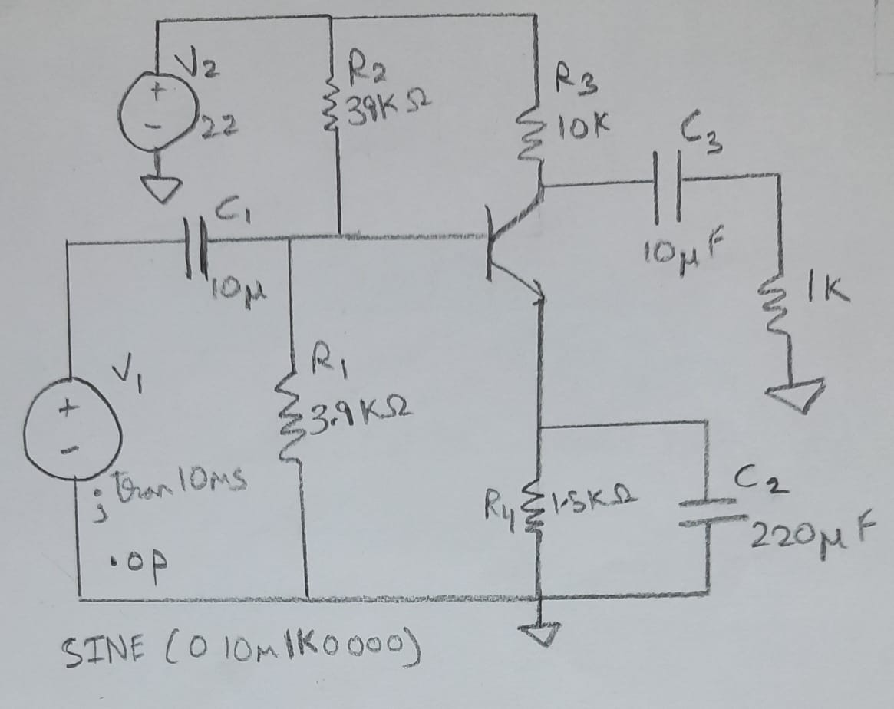

Simulator Diagram – Schematic:

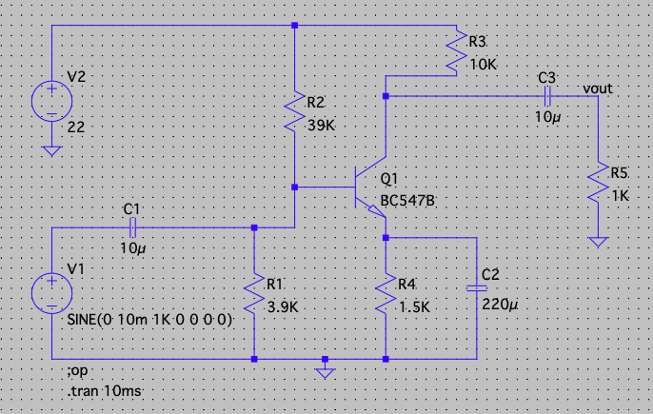

Waveforms: -

Input Waveform: -

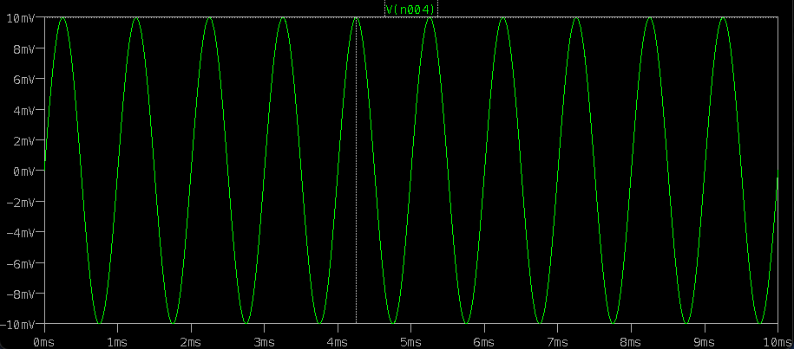

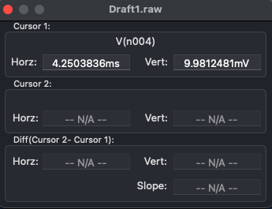 **VIN ~ 10V**

Output Waveform: -

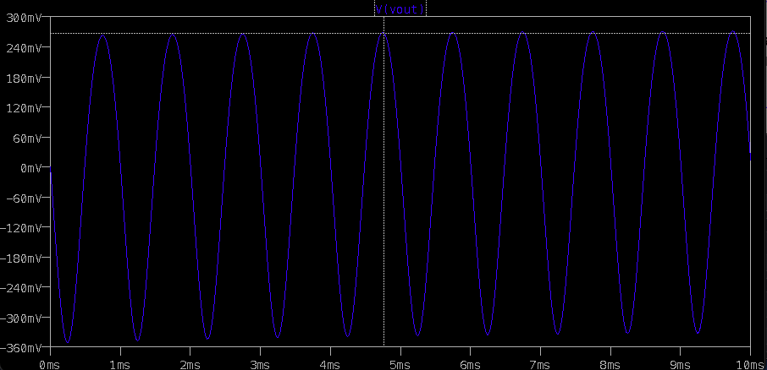

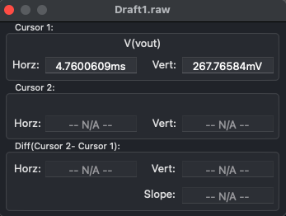

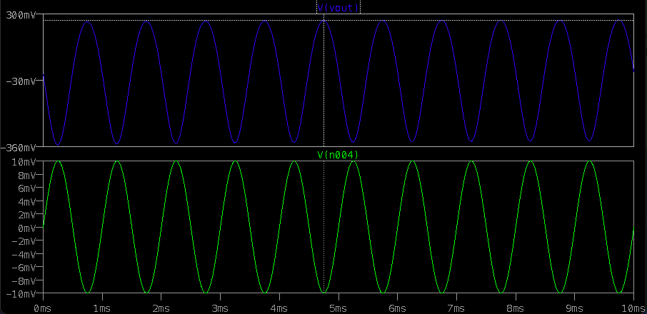

VOUT ~ 268.58V

**Calculations: -**

Voltage Gain = Output Voltage / Input Voltage = VIN / VOUT

Input Voltage given is 10V in AC Sine Simulation

**Input Waveform: -**

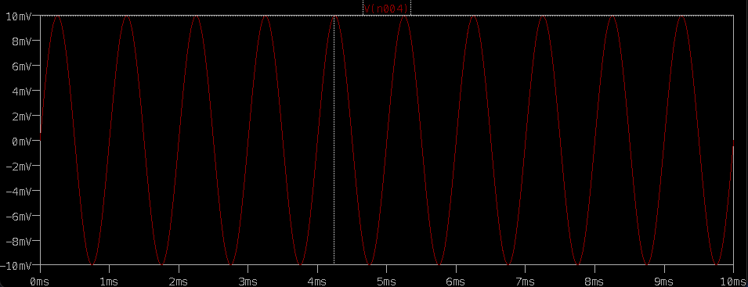

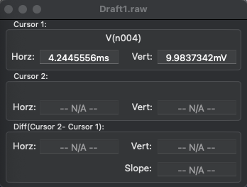 VIN ~ 10V

**Output Waveform: -**

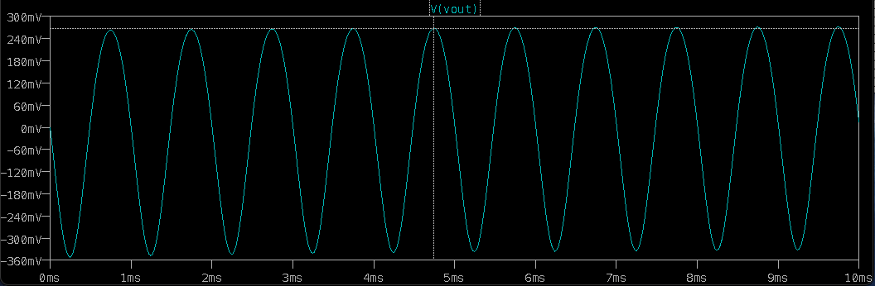

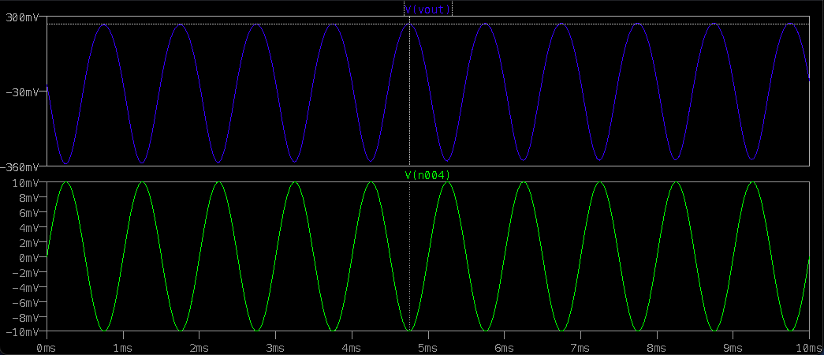

 VOUT ~ 268.58383V

Therefore Voltage Gain = 268.58383/10 = 26.85383

Phase Shift = -180 degree

**INFERENCE**

We observe that the input signal which was about 10V has been amplified to about 268V therefore we know that this transistor works like an amplifier with a voltage gain of 26.85383.

The low resistance in input circuit, lets any small change in input signal to result in an appreciable change in the output. The emitter current caused by the input signal contributes the collector current, which when flows through the load resistor RL , results in a large voltage drop across it. Thus a small input voltage results in a large output voltage, which shows that the transistor works as an amplifier. When a signal is applied across the emitter-base junction, the forward bias across this junction increases during the upper half cycle. This leads to an increase in the flow of electrons from the emitter to a collector through the base, hence increases the collector current. The increasing collector current makes more voltage drops across the collector load resistor RC.

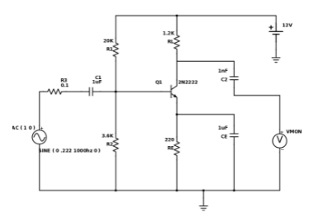 Operation of CE Amplifier

The negative half cycle decreases the forward bias voltage across the emitter-base junction. The decreasing collector-base voltage decreases the collector current in the whole collector resistor RC. Thus, the amplified load resistor appears across the collector resistor. The common emitter amplifier circuit is shown above.

From the voltage waveforms for the CE circuit shown in Fig. (b), It is seen that there is a 180-degree phase shift between the input and output waveforms.

**RESULT:**

**WE HAVE SUCCESSFULLY DESIGNED A CIRCUIT TO AMPLIFY THE LOW LEVEL SIGNAL USING A TRANSISTOR AS AN AMPLIFIER UNDER COMMON EMITTER CONFIGURATION**